## *LiveDewSim: A stream processing* ***experimentation*** *platform for* ***running*** *deep learning on smartphone clusters at the edge*

# Cristian Mateos, Matías Hirsch, Juan Manuel Toloza, Alejandro Zunino

ISISTAN-UNICEN-CONICET, Tandil, Argentina

{cristian.mateos,matias.hirsch,juanmanuel.tolozajuanmanuel.toloza,alejandro.zunino}@isistan.unicen.edu.ar

# Abstract

# Keywords

# Mobile devices, stream processing, deep learning, Dew computing, Android

# Metadata

|  |  |  |
| --- | --- | --- |
| **Nr** | **Code metadata description** | ***Please fill in this column*** |
| C1 | Current code version | *V1.0* |
| C2 | Permanent link to code/repository used for this code version | [*https://github.com/matieber/livedewstream*](https://github.com/matieber/livedewstream) |
| C3 | Permanent link to reproducible capsule | [*https://github.com/matieber/livedewstream*](https://github.com/matieber/livedewstream) |
| C4 | Legal code license | GNU GPL |
| C5 | Code versioning system used | *git* |
| C6 | Software code languages, tools and services used | *Python, Android, shell scripting* |
| C7 | Compilation requirements, operating environments and dependencies | *The emanager_server and scnrunner modules run on Linux-based machines using Python 3.7+; Normapp runs on Android 6+ (it is built using the provided Android Studio project). A full list of dependencies and installation instructions are available at the GitHub site* |
| C8 | If available, link to developer documentation/manual | [*https://github.com/matieber/livedewstream/doc*](https://github.com/matieber/livedewstream/doc) |
| C9 | Support email for questions | [matias.hirsch@isistan.unicen.edu.ar](mailto:matias.hirsch@isistan.unicen.edu.ar) |

# Motivation and significance

# Fog computing [2] was introduced in 2012 to provide highly-scalable network and computing infrastructures for latency and location-aware (mobile) IoT applications, while augmenting resource-constrained devices with processing/storage resources in their proximity. Several alternatives to realize this idea, including cloudlets, mobile edge computing, micro datacenters, nano datacenters and femto clouds, have been introduced [1], which aim at processing data/computations using computing resources located at the edge of the network and optionally using remote resources in the distant Cloud when necessary.

# Since then, there has been a tremendous growth in the amount of resource-rich devices –and hence computational resources- available at the closest edge. According to Statista.com, nearly 84% of the current world’s population owns a smartphone. Modern smartphones contain, on average, more than a dozen sensors, up to eight cores, and powerful GPUs. Likewise, thousands of purpose-specific sensing devices such as surveillance cameras, smoke detectors, noise detectors, and so on are being deployed across buildings and cities around the globe. This has led to another paradigm shift by which relying on not-so-close fog servers to support IoT applications consuming and processing the streams of data from such devices might not suffice. This is particularly true considering that today’s IoT applications are becoming more commonplace and intelligent, and therefore the timely and efficient execution of increasingly complex tasks and the context-aware processing of larger amounts of data in urban scenarios is needed, which is difficult for centralized clouds and challenging even for fog infrastructures.

Dew computing proposes to establish clusters of mobile devices at the very edge [3], as a form of “ubiquitous and opportunistic computing” within data sensing contexts, specially in public places -transport, classrooms, coffee shops- where many nearby devices are present. Hence, cost-effective platforms for intelligent IoT applications emerges provided computational resources are managed wisely. Therefore, platforms and tools to study the individual/collective capabilities and limitations of smartphones for intelligent data stream processing are needed.

We present a software platform to support experimentation with a specific but broad family of such applications, i.e. those using deep learning over data streams. The software allows users -in-lab Dew researchers- to specify automatic, repeatable batch benchmark plans, while indicating specific smartphone-ready deep learning models and task scheduling algorithms for the cluster. Even when we have already proposed a Dew simulation software [3], our framework represents the first step towards “in vivo” benchmarking of mobile devices for such applications, pretty much like commercial platforms such as BrowserStack [4] and LambdaTest [5] allow users to create in-Cloud device farms with the goal of test automation of web and mobile applications. The scientific value of this experimentation platform is threefold, namely to allow researchers to a) realistically characterize and compare smartphone hardware capabilities when it comes to executing deep learning codes over arbritrary data streams using multi-core CPUs and GPUs, b) to experiment with different cluster settings and task scheduling criteria, and c) to gather smartphone profile data that might be in turn employed to feed back our existing Dew simulators, thus creating a *virtuous* *circle* in deriving task schedulers [9]. As we support arbritrary streams and tensorflow models, in practice, derived knowledge using our platform might impact many disciplines where Dew computing is the killer computing paradigm.

# Software description

# Software architecture

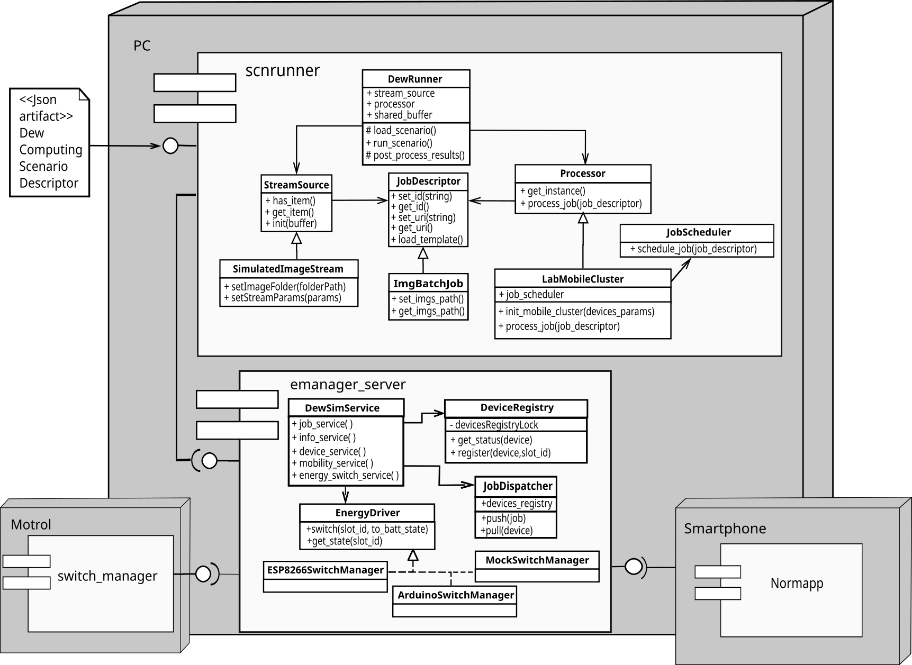

*Figure 1: Arquitectural view of LiveDewStream. The diagram depicts the UML deployment view, and within each node, the UML components and classes modeling the various entities*

From an architectural standpoint, the platform is a client-server software system, complemented with a hardware device called Motrol (see Figure 1). Clients are on one hand the mobile devices being exercised, which run a native Android 6+ application (*Normapp*). Another client is the *scnrunner* module, which parses Dew computing scenario parameters, builds corresponding data streams, derives deep learning-based jobs, decides which node executes which job, and submits jobs to the server and hence indirectly exploiting attached mobile devices.

The server works by assuming an energy managing device -Motrol- for which Python-based drivers are provided. Via its support for dynamic energy supply switching, Motrol allows researchers to automatically repeat/reproduce job set executions involving several smartphones configured with a specific battery level. Currently, we support an USB-interfaced Arduino device called Motrol 1.0 [6], and a WiFi-enabled ESP8266-based microcontroller device called Motrol 1.5 (see Figure 2). A more complex prototype based on the Raspberry Pi 4 Model B, called Motrol 2.0 [7], is under development but it is still not considered in this submission. For example, this model will support USB-charging in addition to AC-charging, a feature missing. In terms of software design, *emanager_server* exposes several Rest APIs. Please refer to the project’s documentation for detailed API specifications in the popular Swagger format [8].

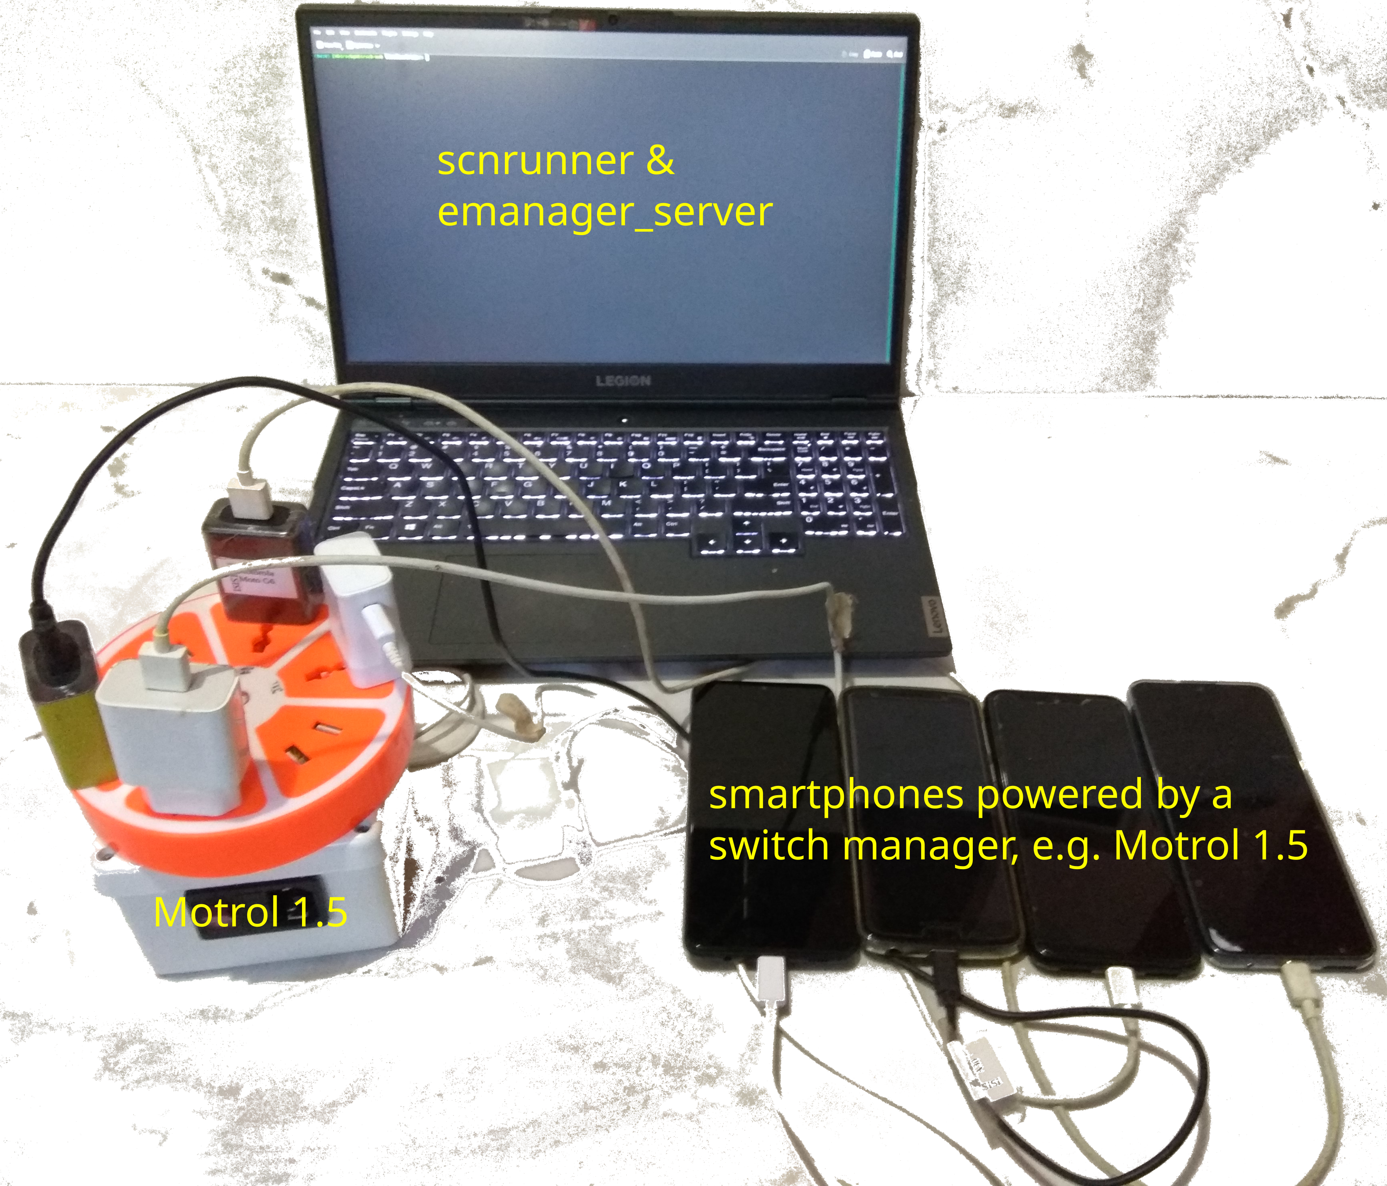

*Figure 2: Dew Computing testbed example*

Motrol 1.0 and Motrol 1.5 use electromechanical relays and provide low-level operations to control energy supply for attached mobile devices. We also provide a mock energy manager to operate the whole platform without Motrol, which prompts the user to manually plug/unplug a specific smartphone[1] from the power grid during test execution as needed. Naturally, this plug/unplug behavior, when using Motrol, remains automatic.

In respect to scnrunner, it is a subproject designed to encapsulate logic that facilitates stream-derived jobs modelling and its online execution using real Dew computing testbeds. Modelling stream-derived jobs consists in generating partitions from a continuous flow of data, for example, a set of images captured within a time window, so its processing is treated by the execution support as an indivisible workload to be run (atomic job). By online execution we mean that once an atomic job is available, a scheduling mechanism is activated to delegate its execution to a smartphone within the Dew cluster. For now, jobs perform object recognition and classification operations with deep learning over images. By extending the *stream.py* module, i.e., providing custom implementations to the *has_items* and *get_item* methods of the *StreamSource* class, new stream types can be supported, e.g., audio streams and text streams.

In conjuntion with *emanager_server*, *scnrunner* eases the reproduction of experimental settings -Dew computing scenarios- to study relevant metrics -throughput, battery utilization, latency- as a result of using different scheduling criteria under real Dew computing environments. An experimental setting is mainly characterized by a workload generation and node states reset. *scnrunner* provides a run.sh script that is the entry point to execute a given set of Dew computing scenarios. The script receives a path to a directory containing Dew computing scenarios descriptor files as the only required argument.

# Software functionalities

Once installed in a PC, the server must be started, by optionally indicating the total number of mobile devices to be employed in the benchmark session. By default, this parameter is the maximum number of smartphones (connecting *slots*) supported by the configured energy device (please see *src/emanager_server/serverConfig.json*).

The server will then initialize each device involved in the session, by asking the user to plug, one by one, each device via USB to the PC. This allows the server to gain root access to the device to a) pushing essential configuration such as server IP address and port, and mostly b) copy and run shell scripts directly on the device that are needed for benchmarks to correctly operate, and c) remotely install (or update) and run our Android application on the device. It is worth noting that tasks a) and b) are performed via the ADB (Android Debug Bridge) [10] tool of the Android SDK, which allows a PC to remotely send commands to a daemon which runs on a mobile device. On the other hand, task c) is done by using ADB in conjunction with Monkey [11], a program that emulate streams of mobile user events such as clicks, touches, or gestures, as well as a number of system-level events. Via Monkey, we launch and (if configured to do so in *serverConfig.json*) start the application automatically.

Once Normapp is installed and launched in the smartphones, the user unplugs each mobile device from the PC and plugs it using its original charger to the configured energy supply hardware -Motrol 1.0 or Motrol 1.5- or to wall sockets -Mock-. Normapp will periodically poll[2] the server via the *DeviceService* Rest API for jobs to execute, execute individual jobs, and submit the results to the server. Job creation and result summarization is done by *scnrunner*.

# Sample code snippets

Figure 3 shows a code snippet of *src/scnrunner/dew_runner.py*, the module with the main method of *scnrunner*. From line 1 to 9 there is logic to parse the supplied Dew computing scenario JSON file and to create the corresponding stream and processor objects. Besides, at line 8, a shared queue is created (and passed as argument to the *build_stream* factory method) to enable stream and processor entities to communicate using a producer-consumer pattern. The *Stream* entity, which acts as an items producer, runs in a separate thread that is started upon invocation of *stream.yield_items()* at line 11. Futhermore, processor entity runs in the main thread consumming items from the shared queue via *jobs_queue.get()* (line 15).

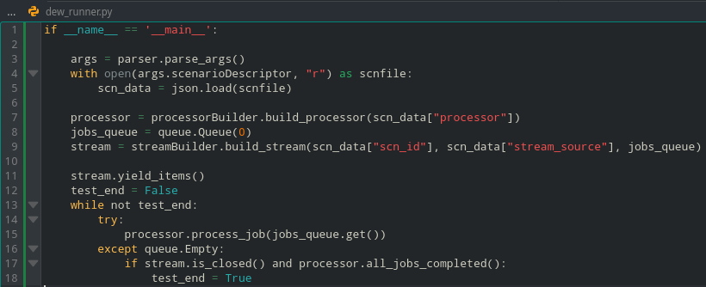

Figure 3: *P*arsing/creating the stream and processor entities declared in scenario descriptor file

# Illustrative example

Figure 4 exemplifies a Dew computing scenario configuration file. The *src/scnrunner/run.sh* script accepts a directory path with at least one of these JSON formatted files. The *scn_id* field identifies the scenario. As can be seen in lines 4 and 5, *scn_id* is used to name the results directory and an output log file, all created by the platform and where it stores scenario execution related information. From lines 6 to 20, the JSON contains configuration parameters of the stream entity mentioned in Section 2.3. For instance, *img_folder* indicates the path where input images are located within the filesystem, *per_job_frames*, *per_burst_jobs*, *millis_btw_jobs* and *millis_btw_bursts* are parameters used to shape the stream speed and load introduced to the system. In the example, jobs are composed of 30 consecutive frames and these jobs are generated every one second (*millis_btw_bursts*). Jobs generation finishes when consumming all images of *img_folder*. Images are served to *Normapp* through a simple HTTP server which can be accessed through the port specified in line 16. Lines 17 to 20 configure the Python class loaded by the platform to create the next job item every time the *get_item()* method is invoked.

The *processor* key is where parameters of the processor entity are configured (lines 26-40). The *hardsupp.mobile_cluster.LabMobileCluster* class is loaded by the platform to perform nodes initialization and jobs scheduling. The class uses the *emanager_server* Rest API. Nodes in this case are four smartphones whose model names and init battery level are indicated under the *devs_batt_init* key. Battery level are values in the range [0-1] being 0 equivalent to 0% and 100% respectively. Besides, “-1” is interpreted as “any battery level”. Lastly, desired scheduling logic is configured by providing the path using dot notation of the class that implements a processor logic, in this case, *job.job_scheduling.RoundRobin*. Paths are indicated relative to where dew_runner.py is located within the LiveDewStream project.

To conclude this example, Figure 5 shows, on top, a sample directory tree of files generated by the platform after running a test. The *scn_id* specified in a scenario descriptor file and the system date are used to identify and create a directory where to locate all output files generated by a test (*dogs_finder_app/results/cs402_scn002/jue_10_feb_2022_15:28:35_-03*). Such directory includes a plain text log containing chronologically ordered events (see sample log at the middle part of Figure 5). Depending on which entity is logging information, entries of the event log are tagged with [STREAM] or [PROCESSOR]. There is also scenario descriptor file information to easily identify which log corresponds to which input parameters. Lastly, the bottom part of Figure 5 shows an example of results.csv file, a file which is built by the platform by merging individual results sent by each mobile device to the emanager_server through the corresponding device service. It contains information of which images were sent to which device, how much time the device spent in downloading input image –inputTransferTime(millis) column-- and performing the inference over the image --inferenceTime(millis) column--. It also records RSSI indicator, battery level at the time of starting downloading images and finish inferences, and the output of the object recognition algorithm itself.

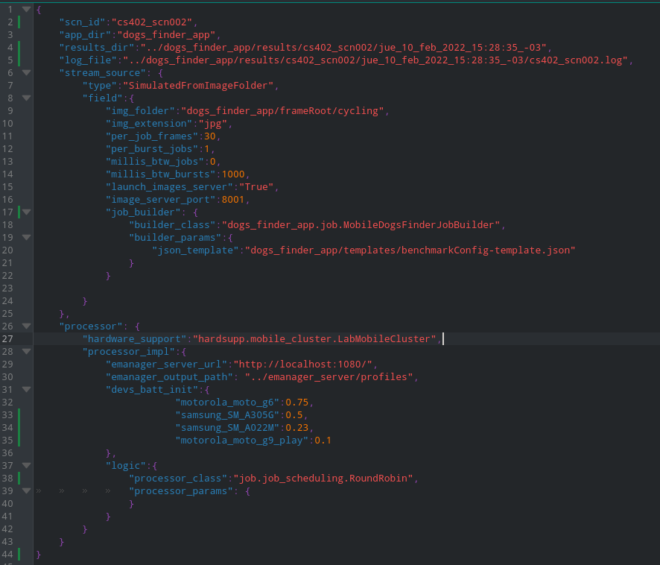Figure 4: Dew Computing Scenario descriptor file

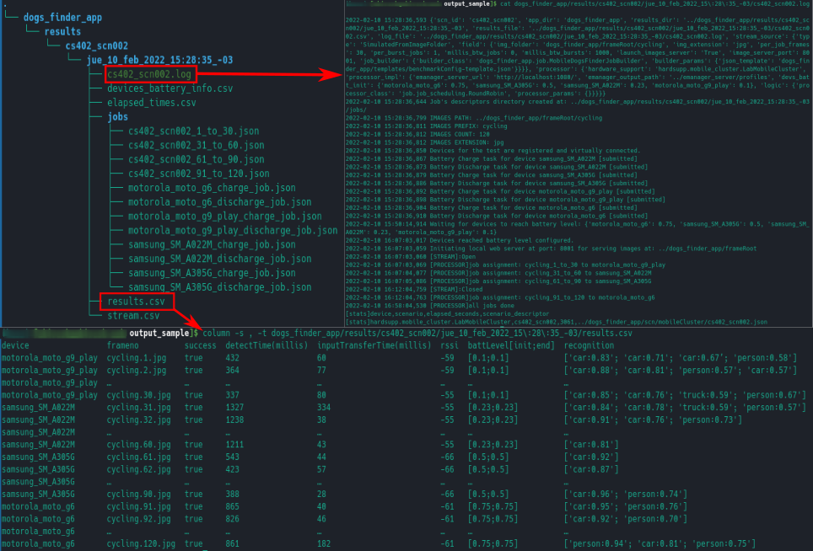Figure 5: Output sample: Directory tree generated, events log and results file

1. **Impact and closing remarks**

Due to the difficulty and time-consuming nature of experimentation on parallel and distributed computing environments, simulation is an accepted practice in the Distributed Computing research community. This is demonstrated by the heavy adoption of simulators for Cloud and Fog computing in the literature. Prominent examples are CloudSim (2011) [12] and iFogSim (2017) [13], which were published in reputed journals, and their seminal papers have reached around 5,500 and 1,200 citations respectively according to Google Scholar. The software projects behind these simulators have also made an impact in the abovementionedresearch community. For instance, CloudSim has generated dozens of satellite/complementary projects (e.g. WorkflowCloudSim) and the official GitHub site[3] has over 400 forks.

In Dew computing, simulation is also a practiced evaluation methodology for studying mobile resource scavenging heuristics [6]. Then, we have proposed DewSim (2020) [1], a trace-based simulation software that uses battery traces to map mobile devices resource utilization levels (e.g. CPU) with battery behavior. Despite having many miles ahead to travel yet, DewSim plus its supporting platform [6] has already shown impact in the scientific literature, as it is the support for many Dew schedulers [9,16], which have been published in reputed journals.

Generally speaking, simulations assume that all the involved elemental processes are known and correct, only then built simulators are fully trustworthy. In practice, however, the relentless developing nature of Cloud, Fog and Dew gradually introduce new fundamental knowledge that challenge the assumptions made by built simulators. This means a) new versions of specific software modules have to be built, or b) integral software modifications must be carried out in order to comply to certain validation experiments. For example, a trace-based file transfer model has been proposed for CloudSim [14], and the sub-optimal accuracy of the simulator as a whole when modeling resource heterogeneity has been evidenced [15].

Precisely, the software platform proposed in this paper provides a testbed for deriving such fundamental knowledge, so the modules of DewSim can be correctly evolved, and proper validation experiments can be performed. Not to mention that, as the platform targets deep learning codes over data streams on mobile devices clusters, this specific yet general-enough application scenario where Dew computing seems to be the killer paradigm in the near future might increment our current user base.

**Acknowledgements**

We thank Eng. Pablo Sanabria (<https://www.linkedin.com/in/tailmon/?originalSubdomain=cl>) for his assistance regarding running Tensorflow Lite models on Android smartphones.

# References

1. M. Aazam, S. Zeadally, K. A. Harras. Offloading in fog computing for iot: Review, enabling technologies, and research opportunities. Future Generation Computer Systems, 87:278-289, 2018.

2. F. Bonomi, R. Milito, J. Zhu, S. Addepalli. Fog computing and its role in the internet of things. 1st Workshop on Mobile Cloud Computing, pp. 13–16, 2012.

3. M. Hirsch, C. Mateos, J. M. Rodriguez, A. Zunino. Dewsim: A trace-driven toolkit for simulating mobile device clusters in dew computing environments. Software: Practice and Experience, 50(5):688-718, 2020.

4. BrowserStack. <https://www.browserstack.com/>

5. LambdaTest. https://www.lambdatest.com/

6. M. Hirsch, C. Mateos, A. Zunino, J. Toloza. A platform for automating battery-driven batch benchmarking and profiling of Android-based mobile devices. Simulation Modelling Practice and Theory, 109, 102266, 2021.

7. C. Mateos, M. Hirsch, J. Toloza, A. Zunino. Motrol 2.0: A Dew-oriented hardware/software platform for batch-benchmarking smartphones. 45th COMPSAC, pp. 1772-1777, 2021.

8. Swagger: API Documentation & Design Tools for Teams. http://swagger.io

9. M. Hirsch, C. Mateos, A. Zunino, T. Majchrzak, T.M. Grønli, H. Kaindl. A task execution scheme for dew computing with state-of-the-art smartphones. Electronics, 10(16), 2021.

10. Android Debug Bridge. https://developer.android.com/studio/command-line/adb

11. Monkey. https://developer.android.com/studio/test/other-testing-tools/monkey

12. R. Calheiros, R. Ranjan, A. Beloglazov, C. De Rose, R. Buyya. CloudSim: a toolkit for modeling and simulation of cloud computing environments and evaluation of resource provisioning algorithms. Software: Practice and Experience, 41(1), pp. 23-50, 2011.

13. H. Gupta, A. Vahid Dastjerdi, S. Ghosh, R. Buyya. iFogSim: A toolkit for modeling and simulation of resource management techniques in the Internet of Things, Edge and Fog computing environments. Software: Practice and Experience, 47(9), pp. 1275-1296, 2017.

14. A. Chai, M. Bazm, S. Camarasu-Pop, T. Glatard, H. Benoit-Cattin, F. Suter. Modeling distributed platforms from application traces for realistic file transfer simulation. In 17th CCGRID, pp. 54-63, 2017.

15. M. Zakarya, L. Gillam. Modelling resource heterogeneities in cloud simulations and quantifying their accuracy. Simulation Modelling Practice and Theory, 94, pp. 43-65, 2019.

16. M. Hirsch, J. M. Rodriguez, C. Mateos, A. Zunino. A two-phase energy-aware scheduling approach for cpu-intensive jobs in mobile grids. Journal of Grid Computing, 15(1), pp. 55-80, 2017.

1. Under this operation mode, smartphones must be connected directly to the power grid
2. A more efficient, push-notification like webhook for Normapp will be developed in the future
3. https://github.com/Cloudslab/cloudsim